4.5 Exploring The Properties of Exponential - Consult page 242 for help
1. Create a table of values for each of the following function for $-3≤x≤5.$
2. Calculate the first and second differences.
$$x$$ | $$y=x$$
-3
-2
-1
0
1
2
3
4
5

$$x$$ | $$y=x^{2}$$
-3
-2
-1
0
1
2
3
4
5

$$x$$ | $$y=2^{x}$$
-3
-2
-1
0
1
2
3
4
5

3. Describe the difference patterns for each type of function. Which function is growing the fastest?

4. Instead of subtracting (bottom – top) which operation could you do in the last table to get a common number?

5. Graph each function on the graph paper below and draw a smooth curve through each set of points. Label each curve with the appropriate equation. (let x axis jump by 1, and y axis jump by 2)

5. State the domain and range of each function.
$y=x$ D = R=
$y=x^{2}$ D = R =
$y=2^{x}$ D = R =
6. Using graphing technology (See possible sites at the bottom of page 4), graph the functions$y=2^{x}$ $y=7^{x}$and $y={20}^{x}$. (to graph $y=2^{x}$, enter 2 ^ x)
7. For each function, state the domain, range, intercepts, and the equations of any asymptotes.
$y=2^{x}$ D=
R=
y-int=
x-int=
Asymptotes:

$y=7^{x}$ D=
R=
y-int=
x-int=
Asymptotes:
$y={20}^{x}$ D=
R=
y-int=
x-int=
Asymptotes:
8. What do all three functions have in common? What is different about them?

9. Which function increases faster as you trace to the right?

10. Which function decreases faster as you trace to the left?

11. Now graph$y=2^{x}$ $y={\left(\frac{1}{2}\right)}^{x}$and $y={\left(\frac{1}{5}\right)}^{x}$ (you can use .5 and .2)
12. For each function, state the domain, range, intercepts, and the equations of any asymptotes.
$y=2^{x}$ D=
R=
y-int=
x-int=
Asymptotes:
$y={\left(\frac{1}{2}\right)}^{x}$ D=
R=
y-int=
x-int=
Asymptotes:
$y={\left(\frac{1}{5}\right)}^{x}$ D=
R=
y-int=
x-int=
Asymptotes:
13. What do all three functions have in common? What is different about them?

14. Describe how the functions $y={\left(\frac{1}{2}\right)}^{x}$and $y={\left(\frac{1}{5}\right)}^{x}$ differ from $y=2^{x}$.

15. Try graphing $y = {(-2)}^{x}$. Does it work?
16. Consider the two functions and their graphs. Explain how they are the same and how they are different.
$y={\left(\frac{1}{2}\right)}^{x}$ $y=2^{x}$
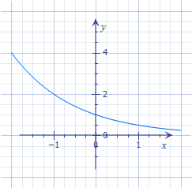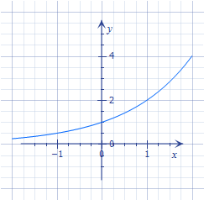

17. What generalization can you make about the relationship between the functions?
$y=a^{x}$ and $y={\left(\frac{1}{a}\right)}^{x}$?

http://isenegger.ca/graphingcalc/
www.fooplot.com
or Google the equation

