4.2 Working with Exponents
PART A: Review
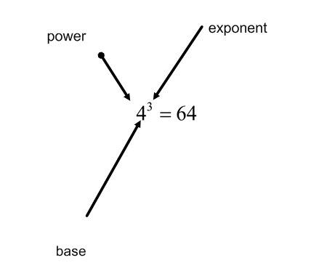
What is the power in the example above? ________________________
What is the base? __________________
What is the exponent? ________________
3 Power Rules
When multiplying powers with the same base, add exponents.
$$3^{4} ×3^{2} =\left( 3 ×3×3×3\right) ×(3×3)$$
$=3^{6}=3^{4+2}$
You try: $4^{7}×4^{3}$
When dividing powers with the same base, subtract the exponents.
$$5^{4}÷5^{2}= \frac{5×5×5×5}{5×5}$$
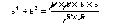
$$=5×5$$
$$= 5^{2}=5^{4-2}$$
You try: $3^{9}÷3^{6}$
To raise a power to a power, multiply exponents.
${{(6}^{2})}^{3}=\left(6×6\right)×\left(6×6\right)×\left(6×6\right)$
$$=6^{6}= 6^{2×3}$$
You try: ${(5^{2})}^{7}$
PART B: Working with Negative and Zero Exponents
Fill in the table below by continuing the pattern. DO NOT USE decimals, use FRACTIONS
Power | Power Evaluated | Pattern
2⁴ | 16 | 16 /2 = 8
2³ | 8 | 8/2 = 4
2² | 4
2¹ | 2
2⁰
2⁻¹
2⁻²
2⁻³

Power | Power Evaluated | Pattern
5³ | 125 | 125/5 = 25
5² | 25 | 25/5 = 5
5¹ | 5
5⁰
5⁻¹
5⁻²
5⁻³

What do you notice about 2⁰ and 5⁰?
Use your calculator to evaluate 8⁰ and 1246⁰?
In general, any number raised to the power of zero is equal to ________.
How do 2⁻¹ and 2¹ compare?
How do 5⁻¹ and 5¹ compare?
How do 2⁻² and 2² compare?
How do 5⁻² and 5² compare?
Does having a negative exponent, make the answer negative?
In general, $b^{-n}= \frac{1}{b^{n}}$
You try: If $6^{5}=7776$, then $6^{-5}=$ ___________
Exercises: Evaluate.
- 5⁻³ =

- (-4)⁻² =

- -3⁻⁴ =

(See page 219 to check your answers)

PART C: Negative Exponents with FRACTIONAL bases.
$${\left(\frac{4}{7}\right)}^{-3 }= \frac{1}{{\left(\frac{4}{7}\right)}^{3}}$$
$$=\frac{1}{\left(\frac{64}{343}\right)}$$
$$=1×\frac{343}{64}$$
$$=\frac{343}{64}$$
There is a faster way! Just flip the fraction base (take the reciprocal) and make the exponent positive.
You try: ${\left(\frac{2}{3}\right)}^{-3}$
Check your answer on page 220.

PART D: Multi-step Problems
Evaluate $\frac{{\left(5^{3}\right)}^{-2}}{5^{-4}×5^{6}}= \frac{5^{3×-2}}{5^{-4+6}}$
$$=\frac{5^{-6}}{5^{2} }$$
$$=5^{-6-2 }$$
$$=5^{-8 }= \frac{1}{5^{8}}= \frac{1}{390625}$$
You try: $\frac{3^{5}×3^{-2}}{{(3^{-3})}^{2}}$.
Check your answer on page 220.
Homework: 1c,d,e; 2a,c,f; 4b,d,e; 5b,d,e; 6b,d,e; 7a,b,c; 8d,e,f;9, 11b,d; 13

