**Isometric and Orthographic Drawings**

We are going to investigate three possible ways to accurately represent a rectangular prism with these dimensions:

3m (length) x 2m (width) x 1m (height)

**1. Isometric Drawing**

An isometric drawing is a 2-D representation of a 3-D figure. The drawing looks like the 3-D figure has been rotated to a corner view so that you can see the top, front, and right side of the figure on an angle.

This is what the given rectangular prism would look like as an isometric drawing with a scale of 1 unit = 1 metre. The scale must always be stated, or the dimensions should be shown on the drawing.

. . . . . . . . . . . .

. . . . . . . . . . .

. . . . . . . . . . . .

. . . . . . . . . . .

. . . . . . . . . . . .

. . . . . . . . . . .

. . . . . . . . . . . .

. . . . . . . . . . .

. . . . . . . . . . . .

. . . . . . . . . . .

. . . . . . . . . . . .

. . . . . . . . . . .

. . . . . . . . . . . .

. . . . . . . . . . .

. . . . . . . . . . . .

To create an isometric drawing, draw the edges of the sides of the object along the angled lines. Each segment of a line is related to one unit of measurement.

Draw an isometric drawing of a rectangular prism that is 2m x 4m x 5m in the space above.

**2. Isometric Perspective Drawing**

An isometric perspective drawing is another way to represent a 3-D figure in a 2-D drawing. It is similar to an isometric drawing, but all of the parallel sides of the figure are slanted off to a point to make the object look more realistic.

This is what the rectangular prism would look like as a perspective isometric drawing.

To create an isometric perspective drawing, draw the front view of the object as you would with an isometric drawing. Then pick a point away from the object and angle all other lines towards this point.

Try drawing the 2m x 4m x 5m rectangular prism in this way in the space below.

**3. Orthographic Drawing**

An orthographic drawing gives a 2-D representation of a 3-D object by displaying what it looks like when viewed directly from the top, front, and right side.

This is what the rectangular prism would look like in an orthographic drawing. It is drawn on graph paper with a scale of 1 unit = 1 metre. The scale must always be stated, or the dimensions of each side should be shown on the drawing.

|  |  |  |  |  |  |  |  |  |  |  |  |  |  |  |  |  |  |  |  |  |  |  |  |  |  |  |  |  |
| --- | --- | --- | --- | --- | --- | --- | --- | --- | --- | --- | --- | --- | --- | --- | --- | --- | --- | --- | --- | --- | --- | --- | --- | --- | --- | --- | --- | --- |
|  |  |  | TOP |  |  |  |  |  |  |  |  |  |  |  |  |  |  |  |  |  |  |  |  |  |  |  |  |  |
|  |  |  |  |  |  |  |  |  |  |  |  |  |  |  |  |  |  |  |  |  |  |  |  |  |  |  |  |  |
|  |  |  |  |  |  |  |  |  |  |  |  |  |  |  |  |  |  |  |  |  |  |  |  |  |  |  |  |  |
|  |  |  |  |  |  |  |  |  |  |  |  |  |  |  |  |  |  |  |  |  |  |  |  |  |  |  |  |  |
|  |  |  |  |  |  |  |  |  |  |  |  |  |  |  |  |  |  |  |  |  |  |  |  |  |  |  |  |  |
|  |  |  |  |  |  |  |  |  |  |  |  |  |  |  |  |  |  |  |  |  |  |  |  |  |  |  |  |  |
|  |  | FRONT |  |  |  | RIGHT SIDE |  |  |  |  |  |  |  |  |  |  |  |  |  |  |  |  |  |  |  |  |  |  |
|  |  |  |  |  |  |  |  |  |  |  |  |  |  |  |  |  |  |  |  |  |  |  |  |  |  |  |  |  |
|  |  |  |  |  |  |  |  |  |  |  |  |  |  |  |  |  |  |  |  |  |  |  |  |  |  |  |  |  |

To create an orthographic drawing, you need to complete an individual scale drawing of each of the top, front and right views. These three views then must be oriented to that you can see which edges line up, as shown in the example above.

Try to draw the 2m x 4m x 5m rectangular prism this way in the space above.

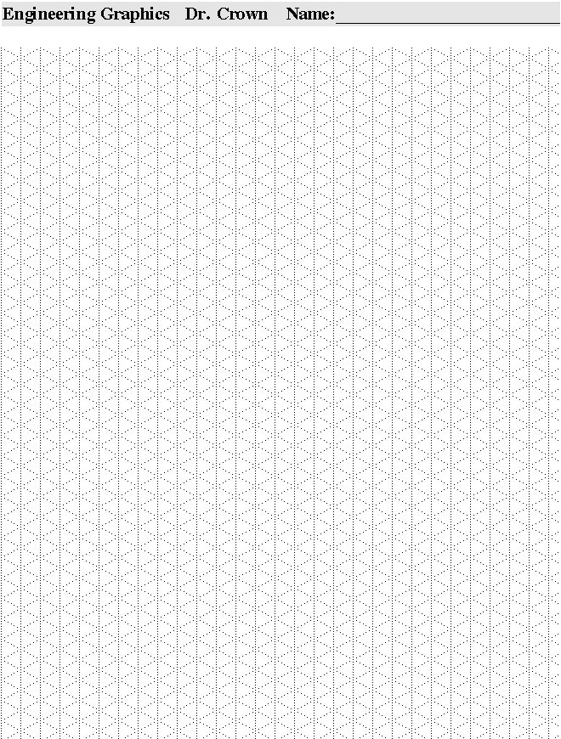

**Isometric Paper**

**Drawings**

1. Draw a rectangular prism with dimensions 3m x 2m x 5m in the following forms:

a) Isometric

b) Isometric perspective

c) Orthographic

2. Draw an isometric drawing of a 30cm x 30cm x 30cm cube with a scale of 1 unit = 3cm.

3. The figure shown is the top view of a couch. Sketch the front and side view of the couch.

**Solutions: the completed drawings as described above.**