3.6 - Factor Theorem and Remainder theorem

PROBLEM 1

Find a factor of
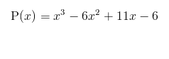
Then use this to help you find all the factors and graph it.

PROBLEM 2
Find a factor of

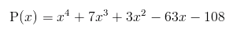
Then use this to help you find all the factors and graph it.

PROBLEM 3

Find a factor of

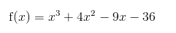
Then use this to help you find all the factors and graph it.

PROBLEM 4

Graph

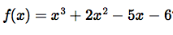

PROBLEM 5:

Graph

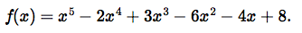

PROBLEM 6:

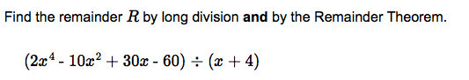

PROBLEM 7:

