Reading Circle Graphs

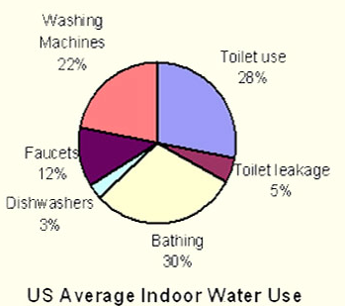
1.

What are the top three things that use up water in the US?

________________ ________________ ________________

What three things together require the same amount of water usage as just bathing on its own?

______________ + _________________ + ________________ = Bathing (30%)

What home repair could you do to save on water usage? ____________________
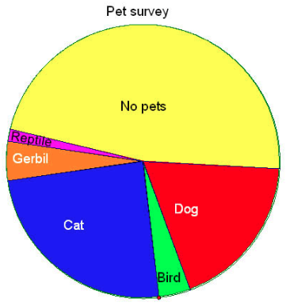

2.

Estimate the percent of people with NO PETS.
_________ %

Estimate the percent of people with a CAT.
__________%

Estimate the percent of people with a DOG.
__________%

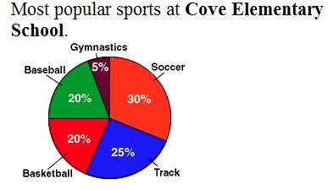
3.

What sport do a QUARTER of the population choose as their favourite? ________

Which two sports together make up HALF of the circle graph?

_____________ and _____________

4.
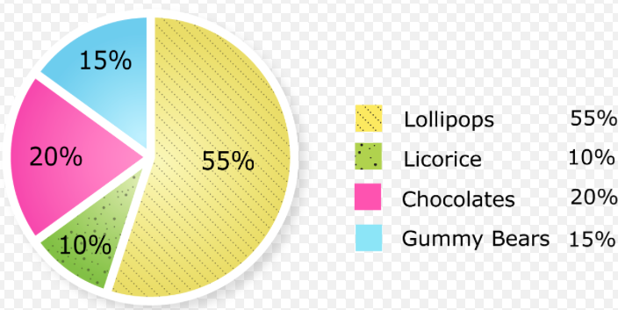

Label the pieces of the pie above with the titles from the legend.

How many times more people choose chocolate over Licorice? _____________

If the data was changed to:
Lollipops 50% Licorice 10% Chocolate 20% Gummy Bears 15% Jelly Beans 5%

How would the circle graph above change?

5.
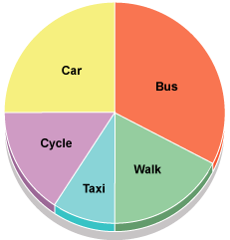

What do you think was the question for this circle graph? _____________________________________

Label the circle graph above with approximated percentages.

6.
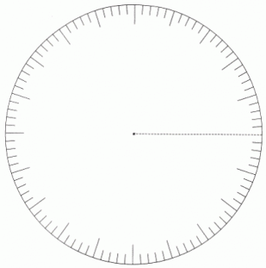
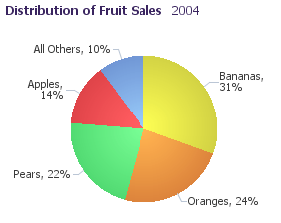

Change the circle graph for distribution of
fruit sales for a tropical country.

