Circle Graph Task
Expectation | R | 1 | 2 | 3 | 4
Solve problems drawn from everyday situations, demonstrating skill and understanding in the use of fractions, percentages, ratios, and rates

Below is a table that shows how a student spends their time in a day. Complete the table and make a circle graph.
 | Sleep | School | Job | Homework | Meals | Entertainment | Total
Number | 7 | 6 | 4 | 2 | 1 | 4
Fraction

Percent
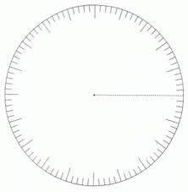

Now, take a survey of the class to see how they prefer to wish a friend “Happy Birthday” when they live in a different city.

 | Phone | Text | Facebook | Letter/Card | Skype | Other
Number

Fraction

Percent

Now, for level 4!!!!!

Make up your own survey question. Survey the class, make a table and make a circle graph.

 | Phone | Text | Facebook | Letter/Card | Skype | Other
Number

Fraction

Percent

