The cylinder and the rectangular prism have the same width and height. Which one has a larger volume?
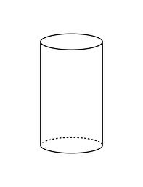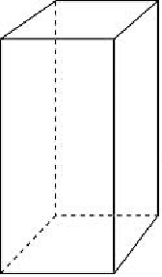

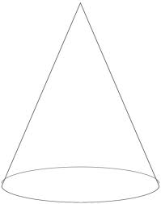
The cone and the cylinder have the same size circle and the same height. How would the volume of the cone compare with the volume of the cylinder?

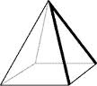

The pyramid and the prism have the same size square base and the same height. How does the volume of the pyramid compare to the volume of the prism?

Which has the larger volume if both bases are equally as wide and they both have the same height?

