Equations to Represent Real Life Situations

Yassine earns $3.00/hour for babysitting his cousin.

At Metro, it costs $2.50 for each bag of chips.

A car can travel 100km per hour on the highway.

When Hawraa does her homework it takes her 2 minutes/question.

Suppose we don’t know how many hours Yassine babysits, or how many chips you buy or how many hours you drive or how many questions Hawraa does.

Represent the 4 different situations with tables. (Add labels for each column)

Yassine earns $3.00/hour for babysitting his cousin.

1
2
3
4
5
6
100

At Metro, it costs $2.50 for each bag of chips.

1
2
3
4
5
100

A car can travel 100km per hour on the highway.

1
2
3
4
5
100
When Hawraa does her homework it takes her 2 minutes/question.

1
2
3
4
5
6
100

Represent the 4 situations with graphs.

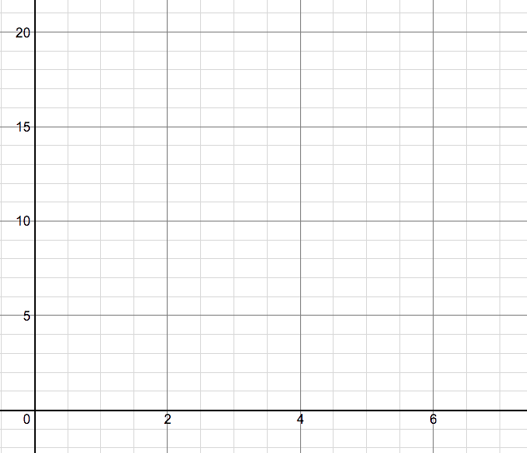 | 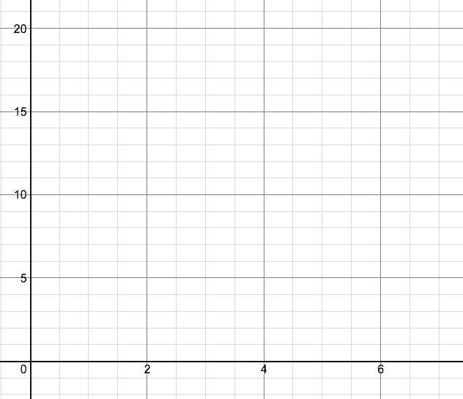
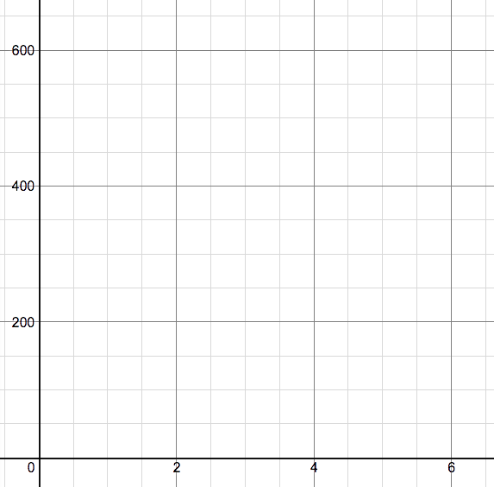 | 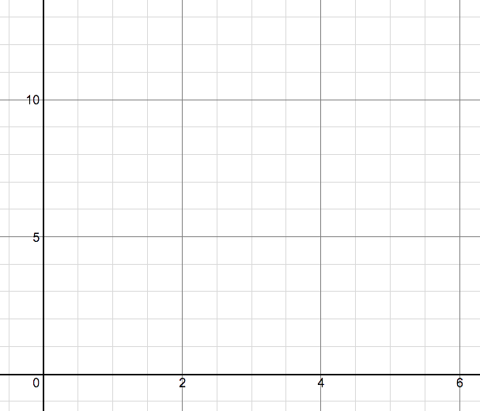
Represent the 4 situations with equations.

