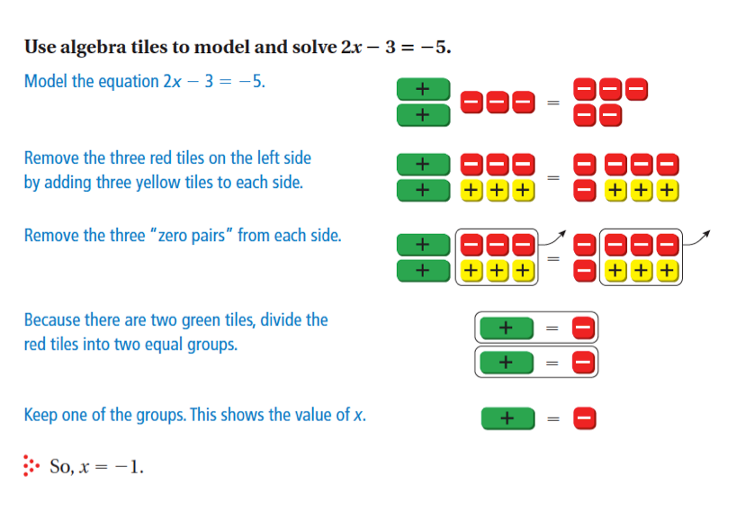

3x – 3 = 6

-2x + 5 = 23

-3x – 6 = -12

4x + 7 = -5

-5x + 3 = 13

2x – 6 = -2

