What happens to the sun in the October?

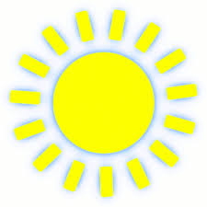

Compare the two tables.
7
6
8
99

8
99
6
7

Compare the two graphs:
On a separate sheet of paper….

1. Use some of the words below to describe what is happening to the sun over time in October.

Increasing, decreasing, relationship, linear, variables, non-linear, correlation, positive, negative, weak, strong, line of best fit, curve of best fit, trend,

2. Predict what will happen to the sun November. Is this extrapolation or interpolation?

3. Pick two variables so that you can study the relationship between the two variables (e.g. time and sunset, time and distance, age and amount of sleeping hours).

4. Use Google to find data (numbers) for the two variables. (Hint: Google the names of the two variables and “table”; e.g. age height table image OR total offensive yards and games played table image)
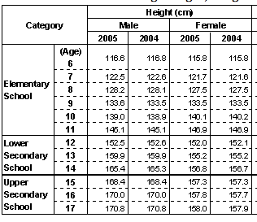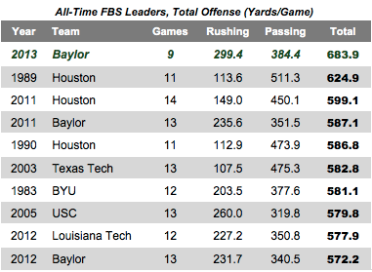
Math Rubric
CRITERIA | LEVEL 1 | LEVEL 2 | LEVEL 3 | LEVEL 4
Knowledge and Understanding  Do I understand the concepts?  concepts |  |  | • Demonstrates considerable knowledge of content and understanding of contents
Communication  Is my answer easy to follow and understand?  Do I follow mathematical conventions?  Do I use specific mathematical vocabulary? |  |  | • Explanations are mostly clear and easy to read  • Uses appropriate mathematical conventions: labels on graphs, headings for tables, etc.  • Uses vocabulary of the unit with considerable effectiveness: uses key words from unit.
Reflecting  Do my answers make sense? |  |  | • Checks to make sure answers are reasonable.  • Explanation includes a statement that shows students have checked that their answer is reasonable and makes sense.

What happens to the sun in the October?

What happens to the sun in the October?

What happens to the sun in the October?

What happens to the sun in the October?

