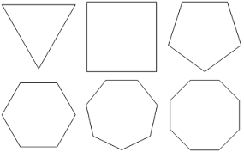

Number of Triangles: Number of Triangles: Number of Triangles:
Total Interior Angles: Total Interior Angles: Total Interior Angles:
Measure of Each Interior Angle: Measure of Each Interior Angle: Measure of Each Interior Angle:
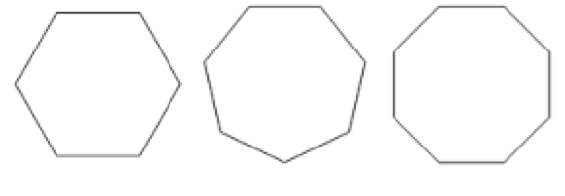

Number of Triangles: Number of Triangles: Number of Triangles:
Total Interior Angles: Total Interior Angles: Total Interior Angles:
Measure of Each Interior Angle: Measure of Each Interior Angle: Measure of Each Interior Angle:

