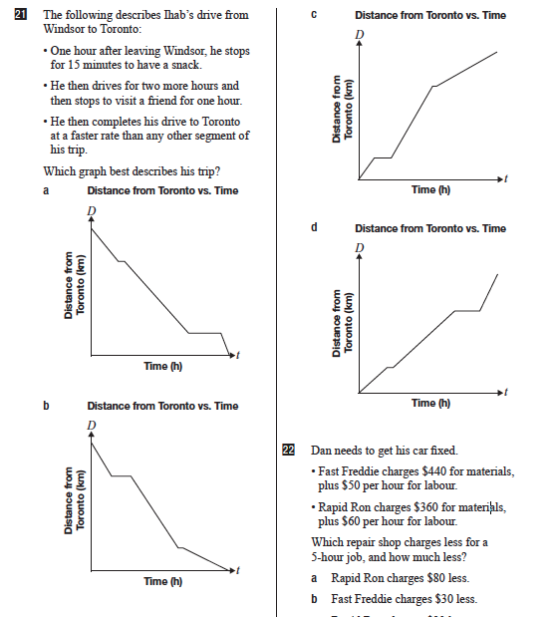

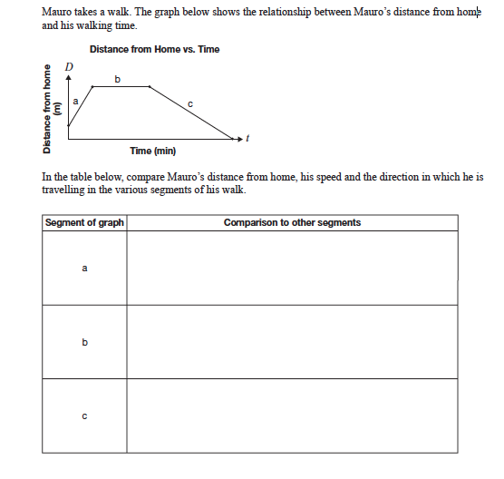

GROUP 1  What is the story?  Calculate all the rates of change.  When is the person going the fastest?  How long do they stop? | GROUP 2  What is the story?  Calculate all the rates of change.  When is the person going the fastest?  How long do they stop?
GROUP 3  What is the story  Calculate all the rates of change.  When is the person going the fastest?  How long do they stop? | GROUP 4  What is the story?  Calculate all the rates of change.  When is the person going the fastest?  How long do they stop?

Start at home.  Move away from home fast.  Stop  Keep moving away from home, but go slow. | Start far away from home.  Move towards home fast.  Get home and stop.  Move away from home again, but go slowly.
Start far away from home.  Move slowly towards home.  Stop in the middle of your trip home.  Then keep walking towards home fast. | Start at home.  Move away from home fast.  Stop  Move towards home slowly.

