**MFM1P - Perimeter Problems**

|  |  |
| --- | --- |
| P = | P = |
| P = | P = |
| P = | P = |

Find the perimeter of the following shape. 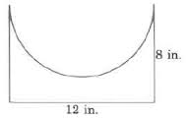

Find an expression for the perimeter of the following two shapes.

