**Linear Relations: Lesson 6b - Rise Over Run**

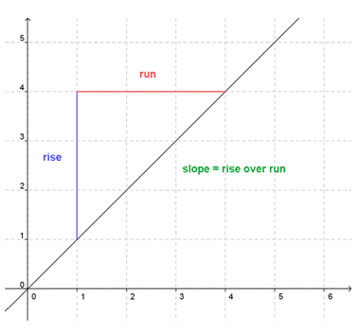

Distance from home (km)

Rate of Change =

RISE/ RUN

or

RISE÷RUN

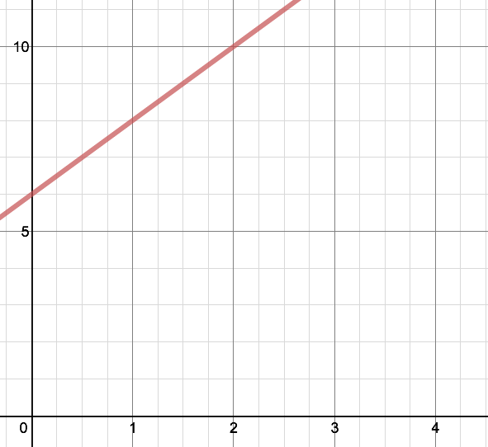

Number of Minutes

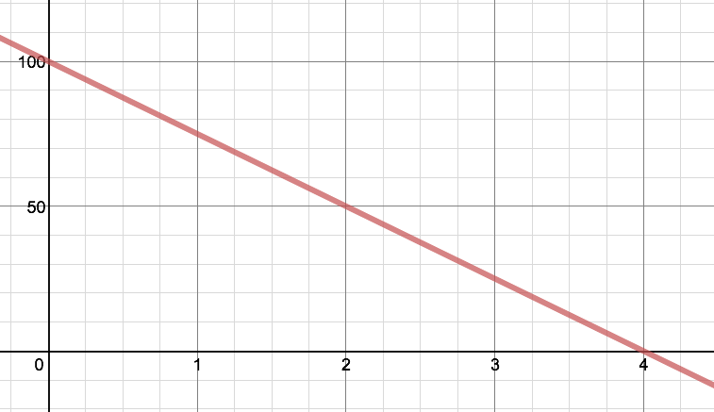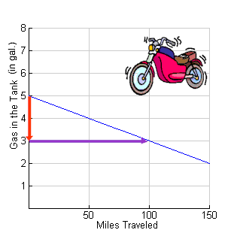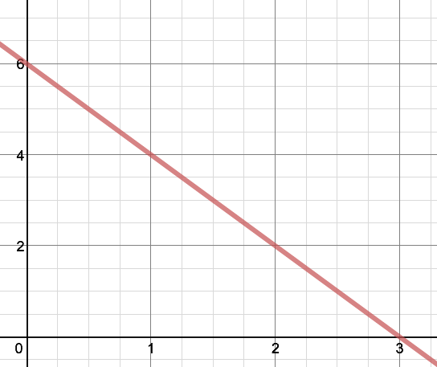

Distance from home (km)

Bank Balance ($)

Number of Weeks

Number of Minutes

|  |  |
| --- | --- |
|  |  |
|  |  |
|  |  |
|  |  |