Linear Relations Lesson #8

How can we solve problems using graphs, tables and equations?
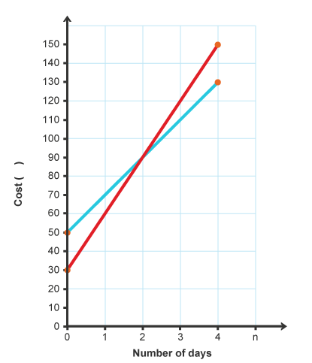
1. Consider the graph for cost of using two companies to rent a riding lawnmower.
a) When do both companies’
lines intersect? ( , )

b) What does the intersection
point represent?
_________________________
_________________________

c) Which company has a higher
rate of change? How can you tell?
__________________________
__________________________

d) Which company has a lower initial
charge? How can you tell? _________

e) Consider the company with initial charge of $30, what will be the cost after 3 days? _______

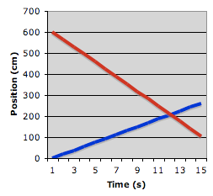f) Consider the company with initial charge of $50, when will the cost be $130?

2. Consider the graph of two people walking.
a) Which of the lines show a negative rate of
change? _________ How can you tell?
______________________________________

b) When will the two people meet and pass
each other? _____________________________

3. The following formula, describes Blaise’s bank balance, B, in $ over time in weeks, w.
B = 40w + 200

- How much money did Blaise start off with in the bank? _________
- How much money does he add each week? _________________
- How much money does he have after 5 weeks?

- When will he have $640 in the bank?

4. The following formula, describes Consolacion’s distance from home, D, in km over time in minutes, m.
D = - 0.25m + 7

- How far from home was Consolacion at the beginning? _____
- Does she walk towards home or away from home? __________
- How can you tell her direction? _____________________________
- How fast is she walking? ____________________________________
- How far from home will she be after 5 minutes?

- When will she be 3.5km from home?

Distance, d, in km | Cost, C, in $
4 | 7
8 | 9
12 | 11
16 | 13
5. Below is a table that shows the cost of a taxi, C, in dollars over distance, d, in km.

- What is the initial cost? __________
- What is the cost per km? _________
- What will be the cost to go 24 km?
- How far can you go for $15?
- What is the cost to go 27km?

