Linear Relations Lesson #7

How can we find the initial value and the rate of change from a sentence, from a table, and from a graph in order to come up with an equation?

Sentences:
It costs $0.75 per banana.

Initial Value: ______ Rate of Change: _________ Equation: __________

Zaina has a starting balance of $300 and she withdraws $25 each day.

Initial Value: ______ Rate of Change: _________ Equation: __________
Initial Value:
____________

Rate of Ch:

Equation:

Initial Value:
____________

Rate of Ch:

Equation:
____________

Tables:
Number of Minutes Walking  m | Distance from Home in meters  D
1 | 1000
2 | 800
3 | 600
4 | 400

Number of Kilometers  k | Cost of Taxi ($)  C
0 | 6.00
5 | 9.00
10 | 12.00
15 | 15.00

Graphs: REMEMBER: To find the rate of change use the formula

Rate of Change = rise/run
Initial Value:
____________

Rate of Ch:

Equation:

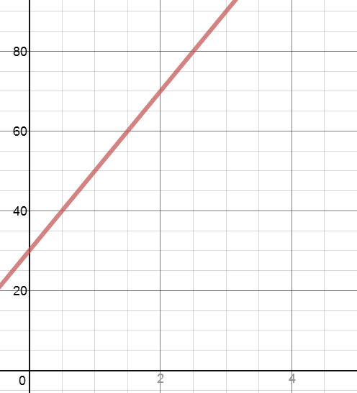

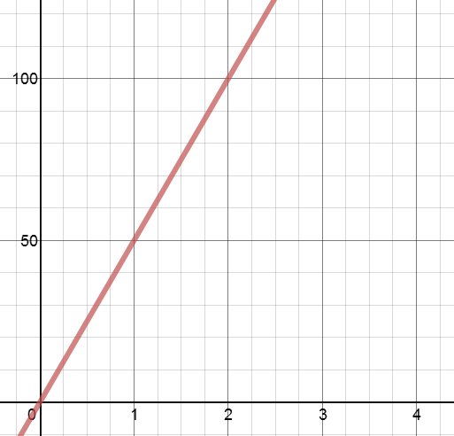
Initial Value:
____________

Rate of Ch:

Equation:

Initial Value:
____________

Rate of Ch:

Equation:
____________

