Graphing Relationships
THIS IS A TABLE OF VALUES

Age | Number of Siblings
15 | 1
15 | 6
14 | 8
37 | 1
34 | 1
18 | 3
17 | 5
18 | 4
20 | 15
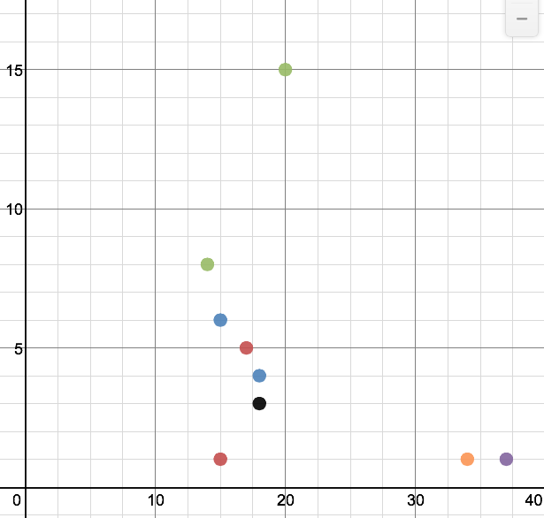
THIS IS A SCATTER PLOT

CORRELATION:
(see the last page)
What is the vertical scale jumping by?
□
What is the horizontal scale jumping by?
□

Is there a relationship between age and number of siblings? _____
How can you tell?
The first column is the The second column is the
horizontal axis. vertical axis.

Age | Number of Years Until Retirement
15 | 50
14 | 51
37 | 28
34 | 31
18 | 47
17 | 48
20 | 45
16 | 49
19 | 46

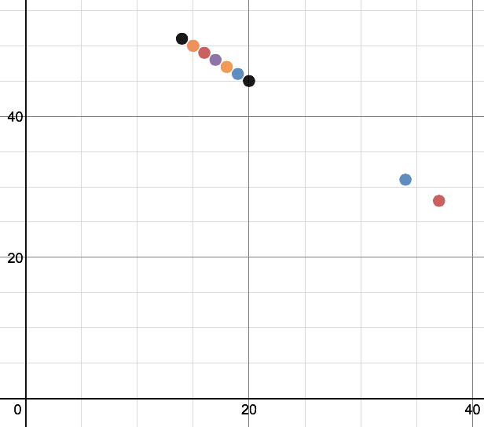
CORRELATION:
(see the last page)
LABEL YOUR AXES!
What is the vertical scale jumping by?
□

What is the horizontal scale jumping by?
□

Is there a relationship between the age and number of year? ______
How can you tell? ___________________
Describe the relationship: _________________________________________________________

Should you draw a line or curve of best fit? _______________ Draw it.
Is the data linear or non-linear?
Age | Number of Years Older than Rachel Thangaraj (she is seven (7)!)
14
15
16
17
18
19
20
37

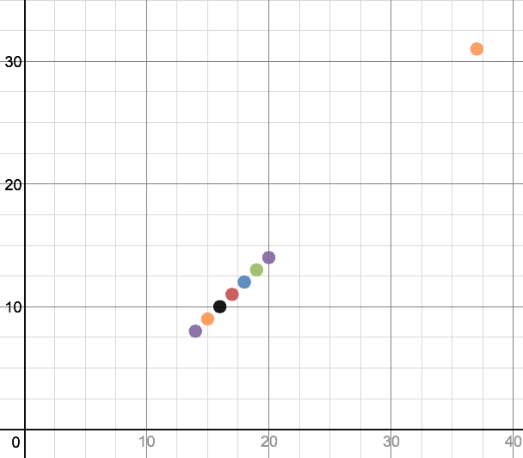
CORRELATION:
(see the last page)
What is the vertical scale jumping by?
□

What is the horizontal scale jumping by?
□

LABEL YOUR AXES!

Is there a relationship between the age and number of year? ______
How can you tell? ___________________
Describe the relationship: _________________________________________________________

Should you draw a line or curve of best fit? _______________ Draw it.
Is the data linear or non-linear?

Time (seconds) | Height of the Ball (metres)
0.5 | 5
1 | 7
1.5 | 10.5
2 | 12
2.5 | 12.5
3 | 12
4 | 7
4.75 | 2
LABEL YOUR AXES!
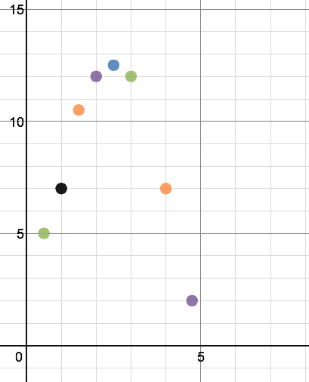
CORRELATION:
(see the last page)
What is the vertical scale jumping by?
□

What is the horizontal scale jumping by?
□

Is there a relationship between the age and number of year? ______
How can you tell? ___________________
Describe the relationship: _________________________________________________________

Should you draw a line or curve of best fit? _______________ Draw it.
Is the data linear or non-linear?
Correlation

Positive Correlation | Negative Correlation
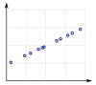  Perfect Positive Correlation | 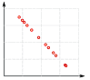  Perfect Negative Correlation
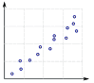  Strong Positive Correlation | 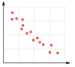  Strong Negative Correlation
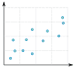  Weak Positive Correlation | 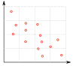  Weak Negative Correlation
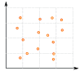 No Correlation

Making Predictions based on our graphs - Use your lines/curves of best fit!

1. Can you predict how many siblings a 30-year-old man will have from graph 1?

2. Can you predict how many years until retirement it is for a person who is 25 from graph 2?

3. Can you predict how many years until retirement it is for a person who is 10 from graph 2?

4. Can you predict the age of someone who will retire in 40 years from graph 2?

5. Can you predict how many years older than Rachel is a person who is 30 from graph 3?

6. Can you predict the age of someone is who 25 years older than Rachel from graph 3?

7. Can you predict how many years older than Rachel is a person who is 40 from graph 3?

8. Can you predict the height of the ball after 2.5 seconds from graph 4?

Interpolation: When you make predictions within (inside) the scatter plot points.

Extrapolation: When you make predictions outside of the scatter plot points

