Simplifying Polynomial Expressions

Algebra Expression | Algebra Tiles Representation | Algebra Expression | Algebra Tiles Representations
1 |  | -1
x |  | -x
x² |  | - x²

Simplify the two expressions.

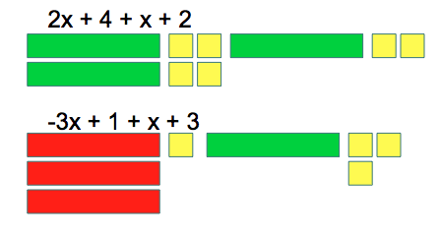

Simplify the two expressions with the help of algebra tiles.

$$2x^{2}– 3x + 1-4x^{2}+2x+3$$

$$-x^{2}-5+3x^{2}+2x+3$$

$$x^{2}– x + 3-2x^{2}+2x-2$$

Adding and Subtracting Polynomial Expression

Adding:

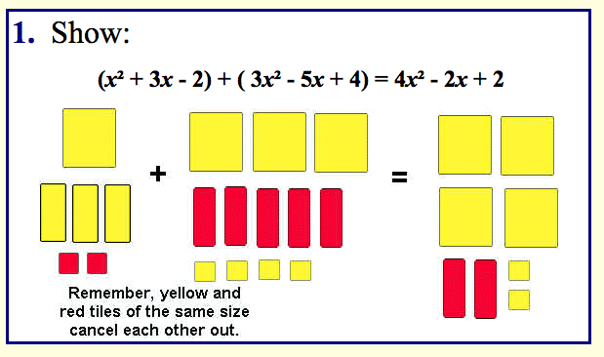

Subtracting:

Subtracting is the same as ADDING the OPPOSITE.

Step 1: SWITH the “-“ with a “+” and take the OPPOSITE of everything in the second bracket (by flipping the tiles)

Step 2: Add the two polynomials as before.
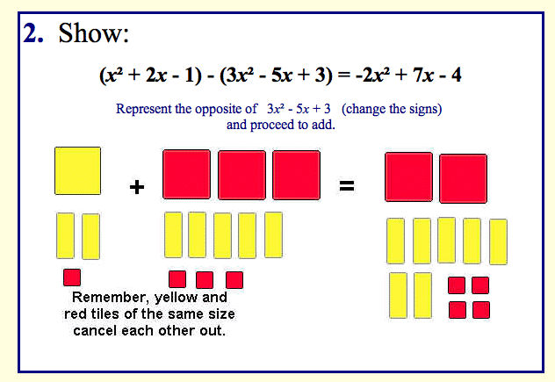

Bonus: Solve for x.

4x – 3 + 2x + 7 = 22

x = 1
x = 2
x = -1
x= 3

