Surface AREA of a Barn

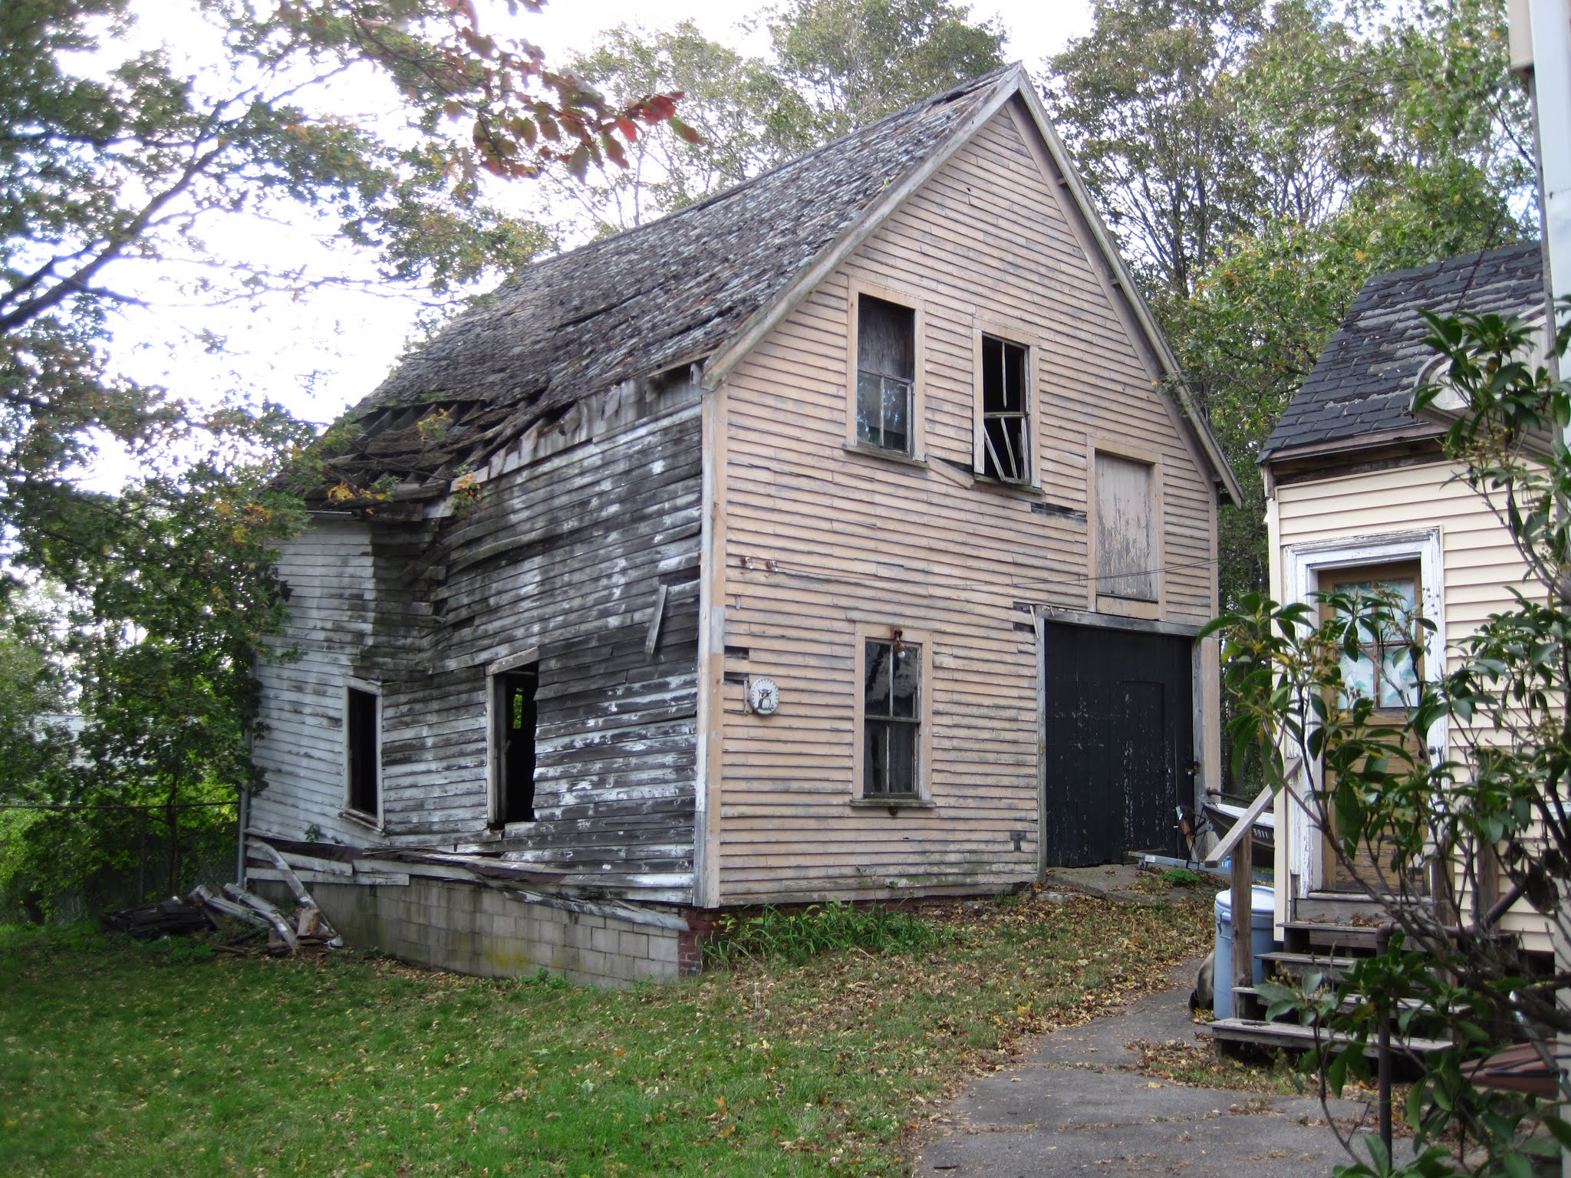

FRONT | BACK
LEFT SIDE | RIGHT SIDE
LEFT ROOF | RIGHT ROOF

How much wood would you need to rebuild the walls of the barn?

How large is the roof if you wanted to have it re-shingled?

