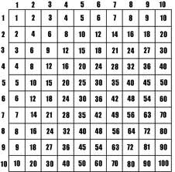
Numeration – Multiplication

Abdullah is buying furniture for his backyard. He buys….
12 chairs for $126 each
2 tables for $276 each
2 umbrellas for $97 each
15 citronella candles for 13 each
How much does he spend in total?

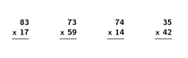

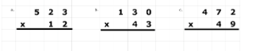

Mr. Walker has $25 000. He has to buy new supplies for the school. He buys…
32 student desks for $239 each
17 teacher desks for $328 each
87 graphing calculators for $116 each
Does he have enough money to buy a SMART board, if a SMART board costs $2500?

