Date: ____________________
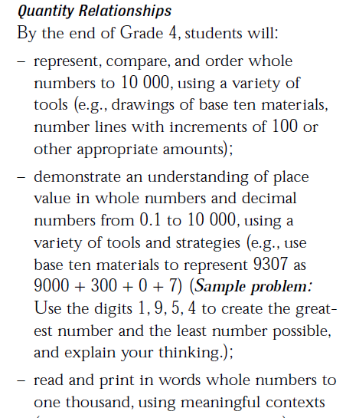

Nasra wants to buy a used Honda Civic.
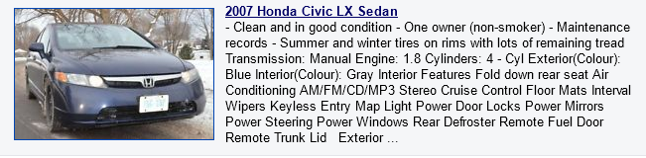
She finds 6 that are for sale in Ottawa.
They are all model year 2007. Below are the prices:

$ 8 999
$9 100
$9 099

$ 9 901
Nine thousand and four dollars
Eight Thousand eight-hundred and ninety-nine dollars.
Order the cars from most expensive to least expensive. Which is the best deal?

