Date: ________________
Diamond needs 5 m of string for an art project.
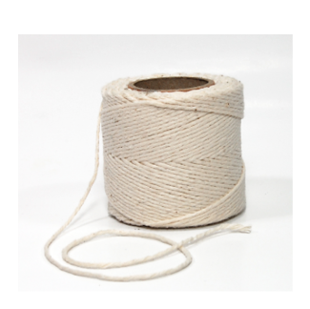
She already has 325 cm string.

What is the length of string Diamond still needs?

Show your work.

Abel and Mohamed go to a store to buy paint and brushes.

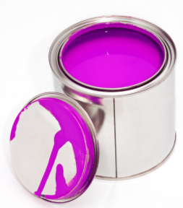 | 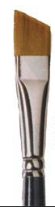
$5/ paint can | $3/ paint brush

Abel buys 1 can of paint and 4 brushes.

Mohamed buys 2 cans of paint and 1 brush.

How much more money does Abel spend than Mohamed?

Show your work.

